SouthWest University
School of Computer and Information Science

Program: Computer Science and Technology
Couse Title: Principle of Programming
Chapter Title: Control
Unit No: 02
Assignment No.: 01

Issue Date: 2021-11-18

Submission Deadline: 2020-11-30

Assessor/Tutor: Li Ya

Student: Cai Qianzhe

Student No.: 222021321102065

NOTES TO STUDENTS
- Check carefully the submission date and the instructions given with the assignment. Late assignments will not be accepted.
- If you are unable to hand in your assignment on time and have valid reasons such as illness, you may apply (in writing) for an extension.
- If you are caught plagiarizing, you could have your grade reduced to zero, or at worst, you could be excluded from the course.
- Your submission document should include screen shots of the Python IDLE showing your code and the output results of running your code.
- Complete your assignment in Word document and submit it to FTP server
- Your file name should start with your Reg. No, and then include your name, and assignment NO. for example “222012321062259_李丹_assignment1.docx”. Remember to link different fields together using the underscore character (_).

Formatting Concerns
#1: You should have a header that explains the program
#2: There should be a space between the prompt and the place where you type in the value.
#3: Your work should be formatted nicely as in the sample output.

STUDENT’S DECLARATION:

I confirm that this is all my own work.

Student Signature: 蔡前哲

Assignment Description
Scenario and Tasks：

1. Puzzle
A famous puzzle follows.
SEND
+ MORE
MONEY
Substitute each letter in the equation with a single integer 0-9 (no duplicates) such that the addition is correct. Write a program to solve this puzzle.
Hint: Brute force works well—try all possibilities.

Solution:

Code:

integ = [0,1,2,3,4,5,6,7,8,9] #用于暴力枚举的数字
vis = [1,1,1,1,1,1,1,1,1,1] #记录当前枚举的数字是否可用
alaph = "aSENDMORY"
num = [0,0,0,0,0,0,0,0,0] #储存字母对应的替换数字

def check():
# send + more = money
#下标：1234 + 5672 = 56328

#当前枚举情况下的三个数
send = num[1]*1000 + num[2]*100 + num[3]*10 + num[4]
more = num[5]*1000 + num[6]*100 + num[7]*10 + num[2]
money = num[5]*10000 + num[6]*1000 + num[3]*100 + num[2]*10 + num[8]

#判断等式成立就输出
if send+more == money :
for i in range(1,9) :
print(alaph[i],"is",num[i])
print()
return

def SetNumber(now):
if now>8: #边界
return

for i in range(len(integ)) : #按顺序给每个字母填所有数字
if i == 0 and now == 5 : #m不能代表0
continue

t = integ[i]
if vis[t] == 1:
num[now] = t #数字还没用过可以用于替换

vis[t] = 0

if now == 8: #填充完成，检查是否合法
check()

SetNumber(now+1) #继续填下一个字母
vis[t] = 1 #回溯，取不到当前数字，标记可用
return

def main():
SetNumber(1) #递归给每个字母赋值替换，按"sendmory"顺序用整数代替字母传参

main()

Screen Capture of The Code:

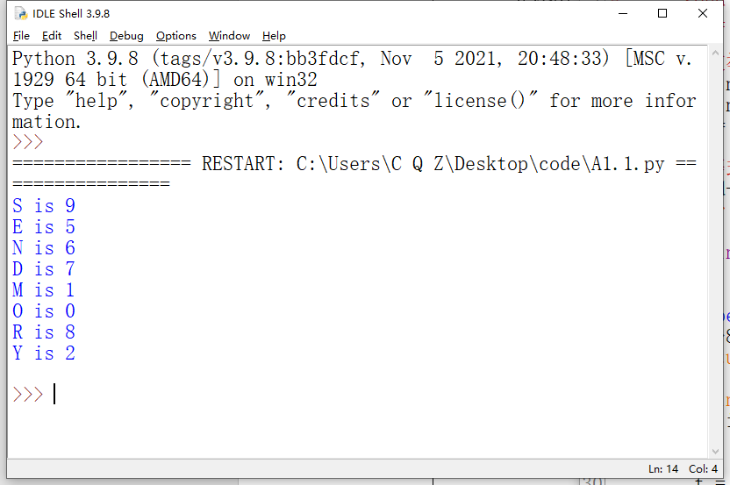
2. Weird multiplication

For this problem, you will be implementing the so-called Russian Peasant or Ancient Egyptian method for multiplication. It looks a little odd, but just think of it as an algorithm, a recipe for doing multiplication in a way other than what you learned in grade school.

The algorithm is as follows. If A and B are the two integers (only integers) to be multiplied, we repeatedly multiply A by 2 and divide B by 2, until B cannot be divided any further—that is, until its value becomes 0 (remember, this is integer division). During each step, whenever B is an odd number, we add the corresponding A value to the product we are generating. In the end, the sum of the A values that had corresponding odd B values is the product. Get it?

Here is an example:
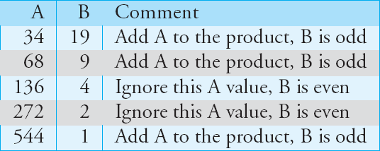

If the two integers to be multiplied are 34 and 19, the operations would be:
Sum up all the A values that had odd B values and you get: 34 + 68 + 544 = 646 => Final product.

(a) Part 1: Write a program to find the product of two integers.

(b) Part 2: Modify your program so that it repeatedly asks whether you want to find another product.

Solution:

Code:

def main():
while 1:
CalculSum = []
#读入两个数，num1是A，num2是B
print("请输入一个数")
num1 = int(input())
print("请再输入一个数")
num2 = int(input()) #向下取整，不要小数
while num2>=2 :
if num2 % 2 == 1 :
CalculSum.append(num1) #B是奇数，把A加入求和序列
num1 *= 2
num2 = int(num2/2)
CalculSum.append(num1) #最后一次结果加入求和序列

#求和输出
ans = 0
for i in range(len(CalculSum)) :
ans += CalculSum[i]
print("这两个数相乘结果是："+str(ans))

#询问是否重复运行程序
repeat = input("\n是否计算其他数(Yes/No)?\n")
repeat.lower() #输入大小写都行
if repeat == "no" :
print("程序退出")
break

main()

Screen Capture of The Code:
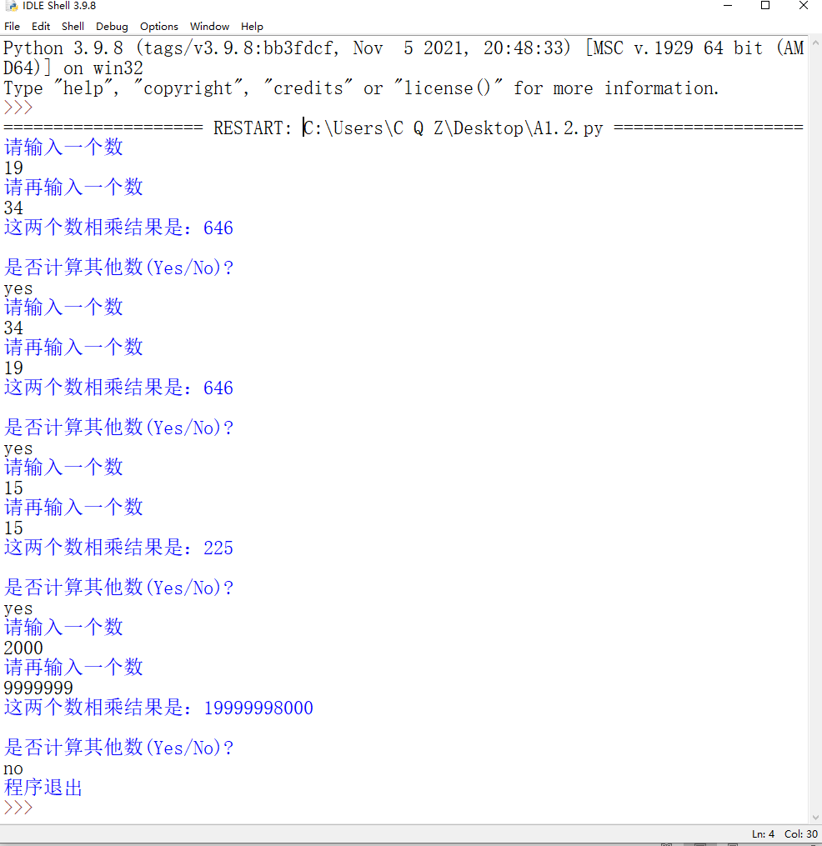
3. Calculate 7/911 to 1000 decimal digits after decimal point.

Solution:

Code:

import decimal

decimal.getcontext().prec = 1000
print(decimal.Decimal(7)/decimal.Decimal(911))

Screen Capture of The Code:
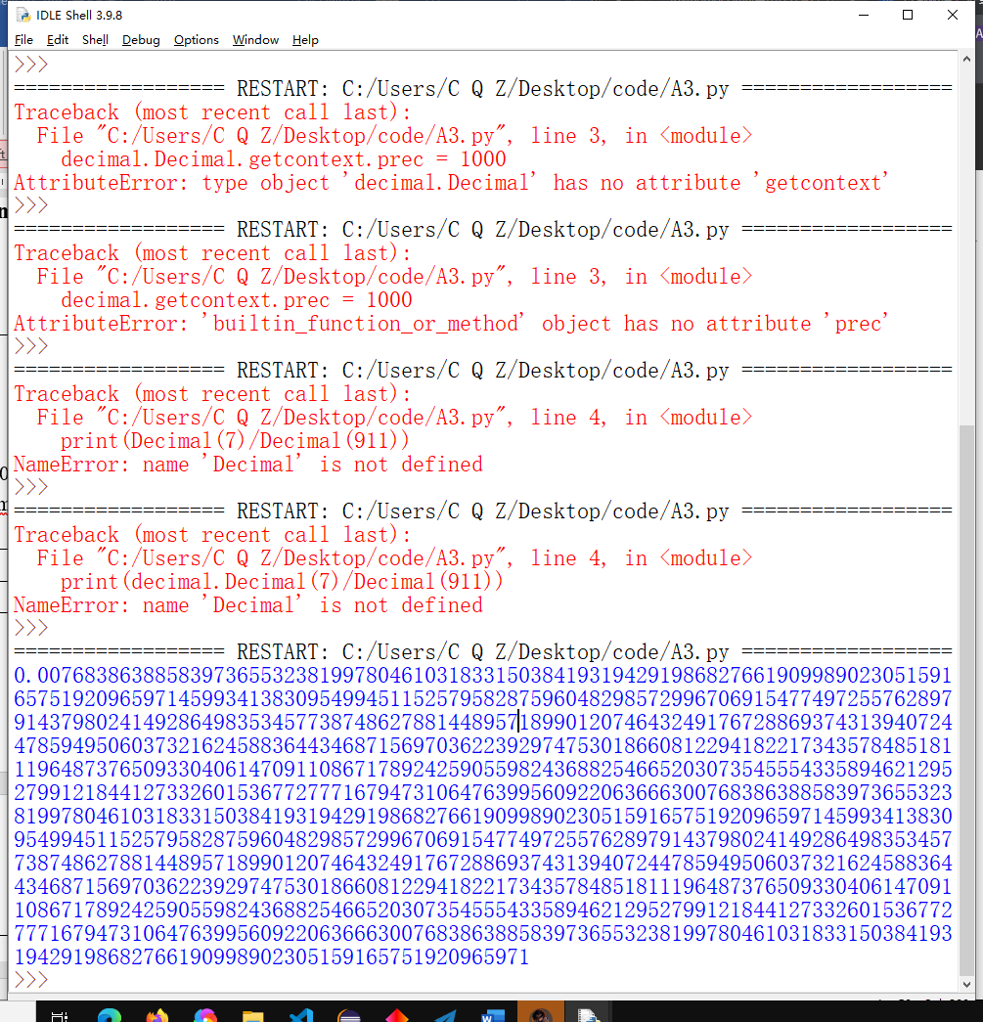

Assessor’s Signature
Date 2021-12-10

